Lecture 12

**SWAP-Extend-Resume Development-Overview**

To locate SWAP

$ df -h

To check swap space

* 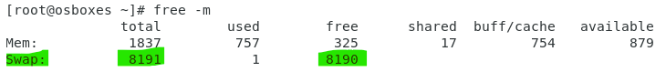
* How to increase SWAP
* A new HDD may be added
* And SWAP and New Partition should be merged.
* And then add its entry in “fstab”
* Use fdisk utility 🡪 create new partition
* Create a new partition 🡪 press “t” to change the type
* 🡪 give “82” which is ID for SWAP (not compulsory but recommended)
* 
* As 82 is the ID of “SWAP” partition
* 
* No need to format this partition using “mkfs” because its not a normal partition.
* Instead
* $ makswap /dev/sdb 🡪 it will make it a SWAP partition
* 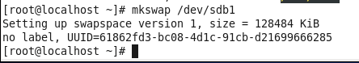
* Now,
* To merg “SWAPs” we need to disable and enable SWAP
* $ swapoff -a 🡪 off
* $ swapon -a 🡪 on

I have extended 700 Mbs to my CentOS 7 VM

(after initial error I reattempted with these steps)

* I made 2nd partition /dev/sdb2 to be swap
* I used “partprob” command to map the newly created partition in file system

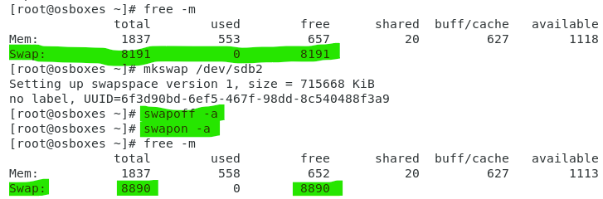

* Another way to display swap partitions.
* $ swapon -s

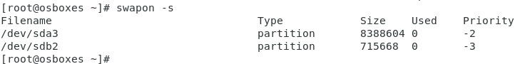

**Swap cab also be extended by creating a file instead of a “partition”.**

**Resume development**

We have learnt so far

* tar
* fdisk
* symlink
* backup
* scan
* permissions

**categories of experience**

3 – 5 years 🡪 write in Resume 🡪 currently working as

* + Linux support Engineer, even if it is not mentioned in offer letter of current job
  + Network support or
  + Application support
    - If HR calls 🡪 I was hired as Network Engineer, but I switched internally and working as Linux support for two year, (HR will allow 100%)

0 – 1 year (fresher)

5 – 10 years